Official use only
Date received
Ref No.
Form ROP2 – application form
The application must be submitted at least 10 working days prior to required date of occupation.

1 | Applicant details
1 | a | Full name
1 | b | Address including postcode
1 | c | Contact telephone number
1 | d | email address

2 | Location of occupation (see below plan) please tick
2 | 1a | Planestanes
2 | 1b | Front of Planestanes
2 | 2 | Queensberry Square
2 | 3 | Fountain area
2 | 4 | Overflow area (blue on plan below) – this area should only be used in the event of areas 2 and 3 being fully occupied
2 | 5 | Other (please specify)
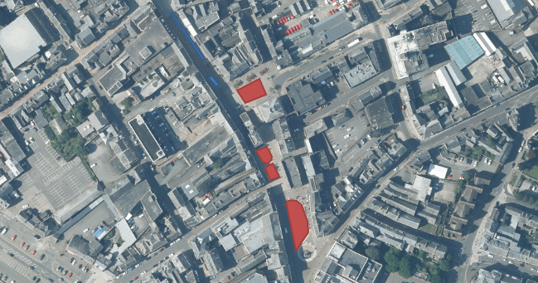

3 | Period of occupation
3 | a | From (Date/Time):…………………………………... | To (Date/Time):…………………………………..…

4 | Event details

5 | Signature …………………………………… | Date ………………………………………….

6 | Return of completed application
6 | Please forward your completed application form, fee (if appropriate), site plan(s), risk assessments and copy of your public liability insurance details to the address below:-  - Roads Service  Dumfries & Galloway Council  EEI  Cargen Tower  Garroch Business Centre  Dumfries  DG2 8PN  or email to  streetworks@dumgal.gov.uk  Payment of any required fee can be made by cheque to the above address or via card payment by calling the following number:  03033 333000 ext. 61563

NOTES FOR GUIDANCE

1 | Applicant details
1 | Please give your full name and address, including postcode, daytime telephone number and e-mail address.
2 | Location of occupation
2 | a | Please tick the appropriate box(es) and/or provide details for the exact location of the proposed occupation
2 | b | Please submit a location plan for the proposed occupation at a scale of 1:1250 or 1:2500
2 | c | Please submit a site plan for the proposed occupation at a scale of 1:500
3 | Period of occupation
3 | a | Please indicate the period of occupation. This will include the date and time you wish the occupation to be valid.
4 | Event details
4 | Please provide as much detail of the event as possible. Including site layout, event timings etc.  Your event may require a licence.  Dumfries and Galloway Council license the undernoted forms of public entertainment:-  - bungee jumping/catapulting  - circuses  - funfairs (5 or more mechanical rides)  - firework displays  - outdoor music events  - a street trader’s licence may be required for the sale of food for immediate consumption  Application forms can be obtained either online at  Public Entertainment - https://www.dumgal.gov.uk/article/15854/Public-entertainment-licences  Street Trading - http://www.dumgal.gov.uk/article/15853/Business-licences  or from  Licensing, Municipal Chambers, Buccleuch Street, Dumfries 01387 245922  Licence applications should be submitted 8 weeks prior to your event.
5 | Signature
5 | Please sign and date the application form
6 | Return of completed application
6 | Your completed application, any additional information and the appropriate application fee* (if applicable), must be returned to the stated address. Failure to do so may result in a delay in processing your application.

* A copy of the current application fees is available on the Council’s website.

